FALCONS P.A. DAY CAMP
GRADES SK - 8

Burlington Campus

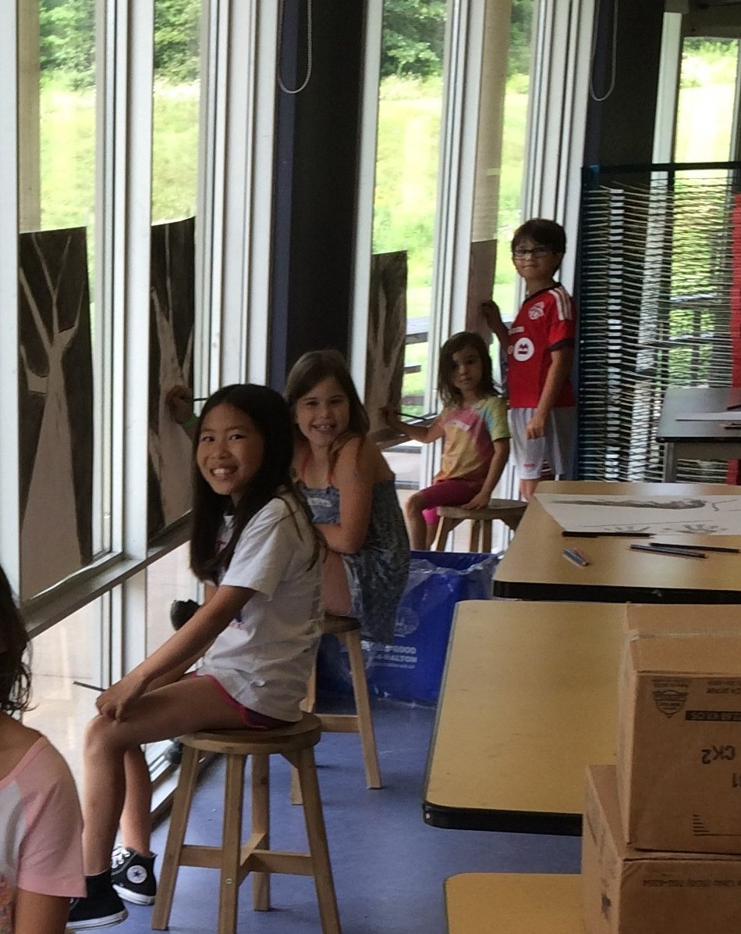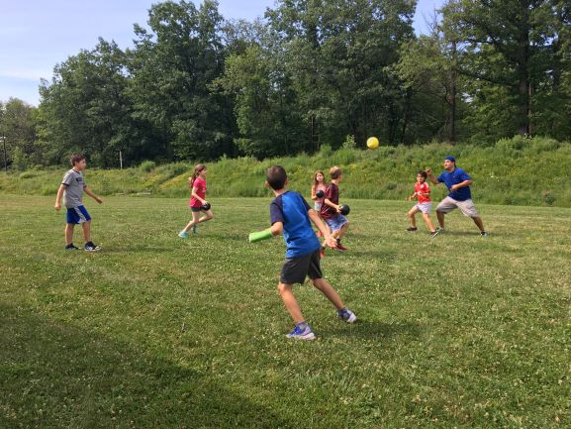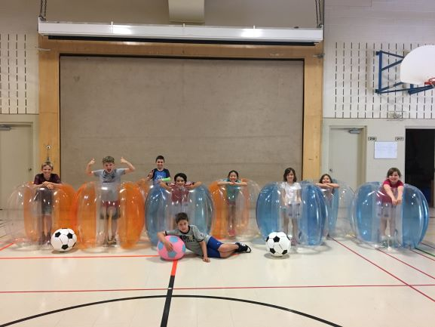

P.A. Day Camps at Fern Hill offer fun and unique programmes for children in Grades SK through 8. Campers are grouped by age with programmes tailored to their specific needs.

An optional bus service will be available. There will be an extra charge for bus service, please see our registration form.
Fern Hill provides a safe, air conditioned environment with state-of-the-art facilities and outstanding instruction by experienced and highly qualified instructors.

FERN HILL CAMP INSTRUCTORS INCLUDE: Frank Bermejo, Fern Hill Staff and Experienced Instructors .
BOOK EARLY TO AVOID DISAPPOINTMENT!
If you have any questions, please contact camp coordinator Mr. Frank Bermejo:
fhscamps@fernhillschool.com
905-634-8652

FERN HILL SCHOOL
Burlington Campus
801 North Service Road
Burlington, ON L7P 5B6
www.fernhillschool.com

WICKED SPORTS
Our Falcons will enjoy the opportunity for skill development and enhance their hand-eye coordination in a fun environment. Kids will engage in sports such as Bubble Soccer, Cricket, Quidditch, Volleyball, Basketball, Baseball, Flag Football and many fun co-operative games.

The Creative Hub brings the best of Creative Insight Pottery and CreativWorks together for the best Children’s Arts & Pottery PA Day Camp around! Half a day pottery, and the other half visual arts! Children will love having the chance to let their creativity shine. Children will be encouraged to explore the whole creative process while learning new skills and making their own creations come to life before their eyes. Children will get to spend time on a real potter’s wheel, and take home their work.

DAILY SCHEDULE
Fern Hill’s camp programmes run 9a.m. to 4p.m. Supervised breaks are provided for all campers.
DROP OFF AND PICK UP
Camp programmes begin at 9 a.m. Upon arrival, we will meet in the gym. Children will be dismissed at 4 p.m. outside the upper doors. Please
ensure that your child is picked up promptly after programmes or extended evening care.
DROP OFF AND PICK UP FOR THOSE WISHING TO USE THE BUSSING SERVICE
Bus will leave Oakville campus at 8:15 am. Camp programme begins at 9am and finishes at 4pm. Bus will leave Burlington campus at 4pm and
arrive back at the Oakville campus at 4:45 pm.
LUNCH AND SNACKS
Campers must provide their own lunches, snacks and drinks. Please ensure that all lunches and snacks are nut/peanut free. You may arrange with Axxis Catering at 905-407-6446, if you are interested in its Camp Lunch programme.
EXTENDED CARE
Before care is available from 8:00 a.m. to 9:00 a.m. at a cost of $5/day. After care is available from 4 p.m. – 5:30 p.m. for $7.50/day. Extended care not available if using bussing service.
CAMP INSTRUCTION
Your child’s camp experience is prepared and delivered by our qualified and dedicated instructors.
CONFIRMATION
Once a completed registration and payment is received, you will be sent a confirmation.
REGISTRATION, HEALTH AND PHOTO RELEASE FORM
The Registration, Health and Photo Release forms must be filled out for each camper.
PAYMENT
Please make cheques payable to Fern Hill School. Cancellations a minimum of two weeks prior to camp date will be refunded, except for a $15 registration fee.
Registration Form

Child’s Name: Current School:
Child’s Date of Birth: Child’s Current Grade:
Name of Parent/Guardian:
Address: ____________________________________________________________________________________________
City ________________________________________________PostalCode_______________________________________
Home Phone: __________________________________Work Phone: _________________________________________
Cell Phone: Email:
Emergency Contact Name(s):
Emergency Contact Number(s):
Name of Person(s) authorized to pick up child:
Relationship of Person(s) authorized to pick up child:
Parent/Guardian Signature:
Note: Incomplete registration will not be processed until all information and signatures are received

Dates | Name of Camp | Number of Children | Sports | Art | *Before Care | *After Care | Bus Service | Total
October 5 | Please circle one: Sports / Art |  | $65 | $75 | $5 | $7.50 | $10
November 9 | Please circle one: Sports / Art |  | $65 | $75 | $5 | $7.50 | $10
December 19 | Please circle one: Sports / Art |  | $65 | $75 | $5 | $7.50 | $10
December 20 | Please circle one: Sports / Art |  | $65 | $75 | $5 | $7.50 | $10
December 21 | Please circle one: Sports / Art |  | $65 | $75 | $5 | $7.50 | $10
February 15 | Please circle one: Sports / Art |  | $65 | $75 | $5 | $7.50 | $10
March 8 | Please circle one: Sports / Art |  | $65 | $75 | $5 | $7.50 | $10
May 17 | Please circle one: Sports / Art |  | $65 | $75 | $5 | $7.50 | $10
June 20 | Please circle one: Sports / Art |  | $65 | $75 | $5 | $7.50 | $10
June 21 | Please circle one: Sports / Art |  | $65 | $75 | $5 | $7.50 | $10
 |  |  |  |  |  |  | TOTAL

* Before & After Care service will not be available for those using the bussing service. Before & After care service will only be available if you are dropping off & picking up your child at the Burlington Campus.

A cheque for the full amount is due with registration. Cancellations a minimum of two weeks prior to camp date will be refunded, except for a $15 registration fee. Please make cheque payable to Fern Hill School.
Medical Consent Statement
PLEASE COMPLETE THE WAIVER FORM BELOW. IT MUST BE COMPLETED ALONG WITH THIS REGISTRATION FORM IN ORDER FOR IT TO BE ACCEPTED.
□ | Yes, in the event that my child is injured or becomes ill during the Fern Hill Camp hours and I cannot be reached, I give my consent to initiate medical treatment as deemed appropriate by the attending physician.

Name: ________________________________________________________________________________________
Health Insurance Number: _________________________________________________________________________
Physician’s Name: ________________________________________________________________________________
Allergies/Medication: ______________________________________________________________________________
Waiver Release
- I understand that my child is involved in inside and outside activities. While every care is given to ensure a safe environment, I do not hold Fern Hill Camp, The Creative Hub, any of its staff or Fern Hill School liable in case of injury or harm, however arising, sustained by my child. If for any reason my child requires medical attention beyond that furnished by the company, I agree to be responsible for any expense incurred.

Parent/Guardian Signature: ______________________________________________________________________
Date: ______________________________________________________________________

Photo Release
- I give Fern Hill the right and permission to publish/broadcast, without charge, photographs/images taken of my child during his/her participation in camp programs and activities. These photographs/images may be used in
Fern Hill publications including brochures, marketing materials, Fern Hill’s website, print advertising and other promotional materials.
Parent/Guardian Signature: _______________________________________________________________________
Date: _________________________________________________________________

Cancellation Policy: A payment of cheque or credit card for the full amount is due upon registration. Cancellations a minimum of two weeks prior to camp date will be refunded, except for a $15 registration fee. Refunds will not be granted for days of camp not attended. Fern Hill Camps will do everything possible to avoid cancellations, however, we reserve the right to cancel a session of camp if the minimum enrollment is not met. In this circumstance, we will accommodate your child in an alternate program/alternate week, if available, or we will provide you a full refund at your request.
Please request an Authorization to Administer Prescribed Medication Form from the school office if your child needs medication to be administered by our staff during program hours.

Card Holder Name: _____________________________________________________________________

Credit Card Number: ___________________________________________________________________

Expiry Date: __________ Security Number: __________ Signature: _____________________________

Description: | Amount:
2% Administration Fee:

CREDIT CARD TOTAL:

