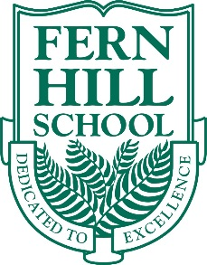
Fern Hill Private School’s mission is to encourage children to be the best students and the best people they can be. We hire OCT certified teachers who are committed to inspiring a love of learning through curriculum that challenges intellectual, social, physical and emotional development of the student.
Fern Hill – Burlington Campus is seeking a qualified French Teacher to fill a part time contact elementary school teaching position beginning September 2020.
Qualifications:
- Bachelor of Education with primary/junior and/or intermediate/senior qualifications.
- Ontario Teaching Certification (OCT) in good standing.
- Qualifications teaching French.
- Excellent oral, written, communication and presentation skills.
- Experience in a private school is preferred.
Characteristics of the Ideal Candidate:
- Creative, innovative, and positive approach to teaching.
- Understands the needs of students and goes beyond the call of duty.
- Excellent classroom management, organization and planning skills.
- Thrives in a positive team environment and easily adapts to new things.
- Communicates with parents, students, and co-workers in a respectful and supportive manner.
- Confident solving problems and providing solutions when issues arise.
- Works with a high standard of integrity.
For more information about Fern Hill School please visit our website at www.fernhillschool.com.
Please send your resume and cover letter to Jennifer Lee at jlee@fernhillschool.com. Only applicants selected for an interview will be contacted.

